PURAVANKARA LIMITED

Quality Management System

HUMAN CAPITAL DEPARTMENT
Exit Process
BPD/15B | Date: 20-02-2016 | REV.NO.01
Prepared by | Team – Compensation & Benefits | Ms Vijayashree Venkat Rao
Process Owner | Head - HC | Ms Anuradha S
Approved by | President- MD’s Office | Mr Jagadeesh K S
Issued by | Management Representative | Mr Vijay Pandey

Table of Contents

Amendment Sheet 3
1. Purpose 4
2. Scope 4
3. Departmental Objectives 4
4. Responsibility 4
5. Definition/Acronyms 5
6. Procedure 6
7. Service Level Agreement 7
8. Flow Chart 8
9. Guidelines for Exit procedure 10
10. Guidelines for Exit Interview 10
11. Guidelines for Full & final settlement 11
12. References 11
13. List of Quality Records 11
14. Annexure 12
14.1 Clearance Certificate 12
14.2 Exit Interview Form 13

Amendment Sheet

DATE | CHANGE DESCRIPTION | REF | PG.NO | NEXT ISSUE/REV.NO
29-05-2014 | BASELINE | ISO 9001:2008 | ALL | REV.NO.00
20-02-2016. | Process Document is revised  Process is aligned with the requirements of  ISO 9001:2016 | ISO 9001:2015 | All | REV.NO.01

Purpose

The document details the process and procedures that an employee is required to follow in event of the employee’s voluntary separation from the organization.

Scope

The process and procedures apply to an employee voluntarily resigning from the organization.

Departmental Objectives

The exit process enables the employer to gather inputs on the employee’s experience in the organization. It also ensures the transfer of knowledge/ Knowledge Transition (KT) from the exiting employee to the assigned individual.

Responsibility

The primary responsibility of the process lies with the process owner (HC-Comp & Ben) and verified by the functional head. The process owner shall ensure that the exit process workflow is executed and adhered to as per the documented procedure.

Definition/Acronyms

MR | Management Representative
HOD | Head of the Department
BPD | Business Process Document
HC-Comp & Ben | Human Capital- Compensation & Benefits
RL | Resignation Letter
Head-HC | Head - Human Capital
HRMS | RAMCO-Human Resource Management System

Procedure

Para no | Activity | Responsibility | Quality Record
6.1 | Employee sends in resignation to the Reporting Manager (RM) /HoD/HC | Employee
6.2 | Acceptance of resignation by HoD subsequent to discussion with the employee | Functional Head
6.3 | Finalization of Last Working Day (LWD) /Relieving Date with employee | RM/HC
6.4 | Exit email/clearance formalities sent to the resignee 20 days prior to LWD | HC
6.5 | Exit interview discussion at least 7 days prior to LWD | HC
6.6 | Follow up call on the clearance formalities 1 day prior to LWD | HC
6.7 | Submission of clearance form and handover documents | Resignee/RM | Clearance Form
6.8 | Exit interview discussion on or prior to LWD | HC | Exit Interview Form
6.9 | Letter of Resignation Acceptance (if requested for) issued to the resignee on LWD, subject to clearance/handing over | HC
6.10 | Full & Final (F&F) Settlement computed | HC
6.11 | Handover of Relieving letter/Service certificate, F&F Settlement cheque sent to the resignee via courier/registered post within 20 working days from the LWD(subject to completion of exit formalities/clearance process)  As per SLA, F&F Settlement Completion targeted at 90% for a financial year | HC

Service Level Agreement

Sl No | Activity | Responsible | Quality Record | SLA
7.1 | F&F Process Begins- Exit process run in HRMS and handed over to Finance | HC-Comp & Ben | F&F Statement* | On 2ndWorking day of every month
7.2 | Computation of F&F and Income Tax deductions and other statutory | Finance | F&F Statement* | 4 working days post receipt of F&F working from HC
7.3 | Preparation of F&F excel statement for the resignee | HC-Comp & Ben | F&F Statement* | 3 working days on receipt of IT computation from Finance
7.4 | On receipt of F&F cheque for the resignee from the Finance team; Relieving Letter, F&F settlement sheet and cheque handed over to the resignee | HC-Comp & Ben |  | within 20 working days from the LWD (subject to completion of exit formalities/clearance process)

*F&F statement is a confidential and private document between the employer and the employee. Hence, this statement shall not be presented for public viewing/review as a Quality Record during the internal audits.

Flow Chart
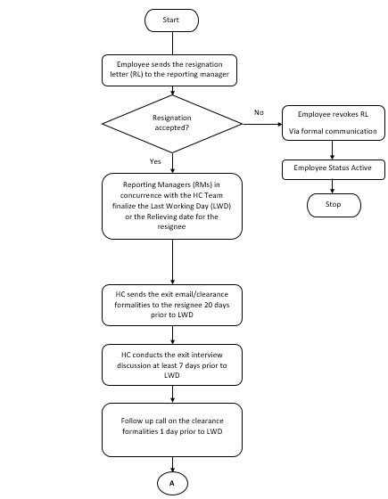

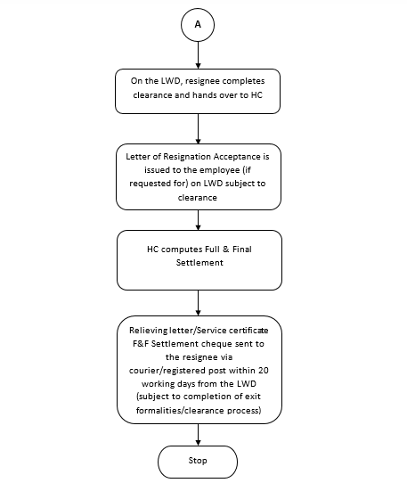

Guidelines for Exit procedure

The Exit process detailed above shall be followed by any employee voluntarily leaving the organization i.e. being relieved from the Puravankara group in accordance with the terms and conditions of the employment agreement.

Notice period & relieving

When an employee resigns, the Reporting Manager (RM)/HoD/Business Head (Biz. Head) shall attempt to understand the reasons behind the resignation, identify and address corrective measures to retain the employee (if possible).

In case it is not possible to retain the employee, the RM in concurrence with the HC Team finalizes the Last Working Day (LWD) or the relieving date for the resignee. The notice period to be served by the resignee will be as per the terms of appointment*:

 | Designation | Notice Period
1. | Upto Manager | 1 month
2. | Sr Manager and DGM | 1 month* (3 months for exceptions)
3. | GM and ABOVE | 3 months*

*Note: -Exceptions to be dealt on a case to case basis

During the notice period, the resignee as well as the Reporting Manager must ensure that the necessary/essential information, related to all the projects or tasks the employee has been working upon is handed over to the designated team member/ employee.

Guidelines for Exit Interview

The Exit interview provides the exiting employee an opportunity to give feedback on the employee’s work experience in the organization. These inputs would be helpful in designing and implementing corrective measures to make the Puravankara group a great workplace.

The HC team conducts the exit interview with the resignee 7 days prior to the LWD.

The exit interview discussion with the resignee is documented and if required shall be shared with the Functional Heads and Executive Board.

Guidelines for Full & final settlement

- The employee shall complete the clearance formalities and get the necessary sign-off on the clearance form from the specific departments.
- The clearance form with the necessary documents must be handed over to the HC on the last working day to enable computation of the full & final settlement.
- The employee’s Full & Final settlement will be processed upon receiving the approved resignation letter and signed clearance form from the respective departments. The Finance/HC team to ensure that the employee’s Full & Final settlements are carried out within 20 days from the Last Working Day, subject to receiving the duly completed clearance form.

References

ISO 9001:2015

List of Quality Records

- Clearance Form
- Exit Interview form

Annexure

Clearance Certificate

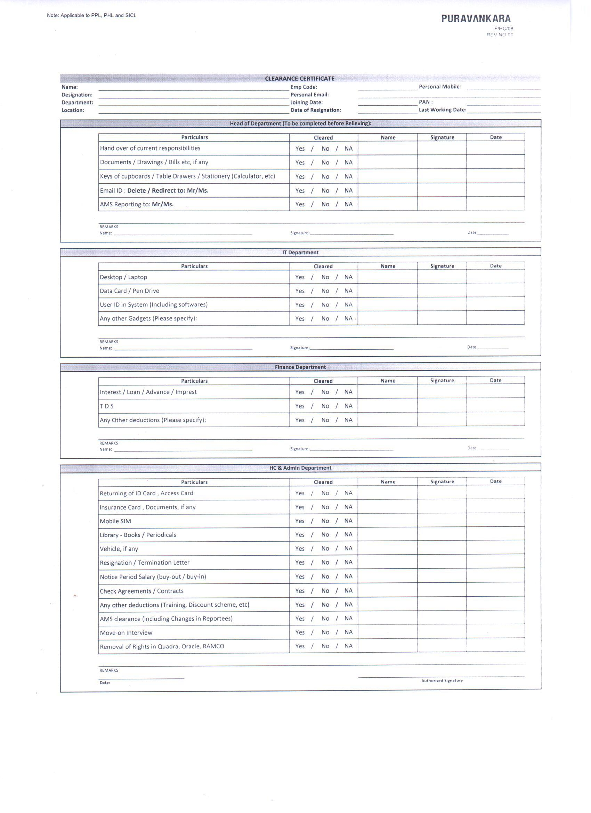

Exit Interview Form
